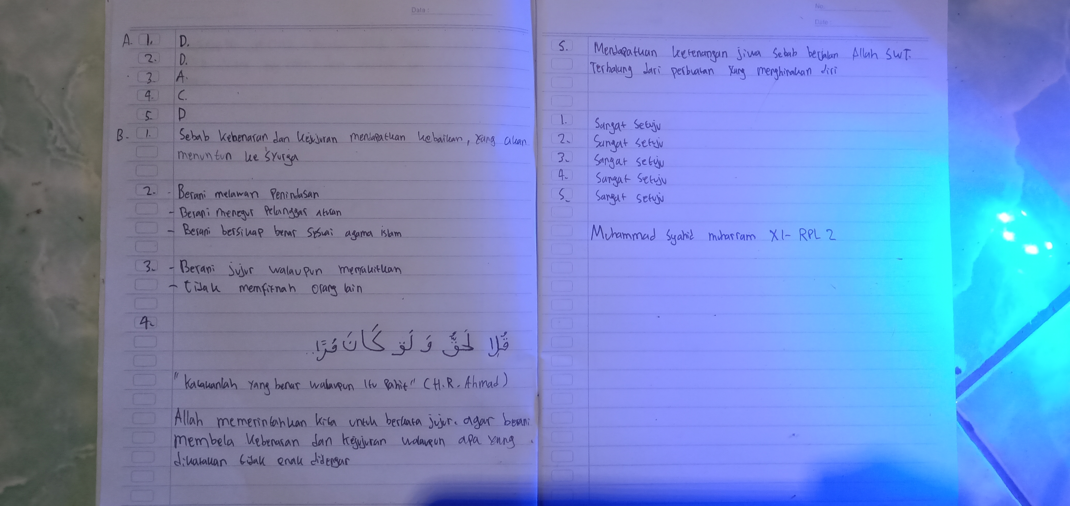
Muhammad Syahid Muharram XI-RPL 2

